Baseband Adaptation v9.6
Subsystem Architectural Description

Status: | Issued
Version: | 3.4
Team/Department : | Cellular Baseband Services/OS Development

Contents
1 Introduction 3
1.1 Purpose and Scope 3
2 Subsystem Overview and Background 4
3 Baseband Adaptation Architecture and API’s 5
3.1 The Subsystem components 5
3.2 General Description 5
3.2.1 Networking/BasebandAdaptation/BCA 6
3.2.2 Telephony/Reference and Test TSYs 8
3.2.3 Telephony/HWRM 9
3.3 Architectural Description and Elaboration 11
3.3.1 HWRM 11
3.4 System Architectural Requirements 12
4 Security 13
4.1 Data caging 13
4.1.1 HWRM 13
4.2 Backup and restore 13
4.2.1 HWRM 13
4.3 Capability ranges 13
4.3.2 HWRM 13
5 Further Information 14
5.1 References 14
5.2 Open Issues 14
5.3 Glossary 14
5.4 Document History 15

Introduction

Purpose and Scope
The Baseband Adaptation v9.6 Architectural Description details the architecture and APIs exposed by the Baseband Adaptation technology stream.
The main audience for this document is anyone who wants an overview of the Baseband Adaptation technology stream architecture and components.

Subsystem Overview and Background
This section provides a general overview of the technology area, including relevant Symbian and external specifications and background information.
NOTE: For the purpose of this document the subsystem being described is the set of components owned, developed and maintained by the Baseband Adaptation technology stream.
The Baseband Adaptation technology stream is the technology area that provides a set of telephony integration modules that help reduce the time to market for licensee products by providing a framework that enables adaptation to different protocol stacks.
For more detailed information on the HWRM component, see [[11].

Baseband Adaptation Architecture and API’s
The objective of the Baseband Adaptation components is to provide a set of telephony integration modules that can be easily ported to systems from other suppliers.
It is also recognised that some customisation will always be required. Licensees will generally want to add a small number of extended features and also cater for situations that are handled differently on each device (for example, power management).
In particular:
- Common differences in protocol stacks should if possible be configurable either at compilation or run time.
- If modifications are necessary, changes should ideally be localised to well-defined areas.
- The framework should allow most extensions to be added by following a standard template or procedure.
The following section detail the components provided by the Baseband Adaptation technology stream.

The Subsystem components
The Baseband Adaptation components are largely plug-in components but there is one framework component (Baseband Channel Adapter) which provides a PublishedPartner abstract interface.
The following table lists the Baseband Adaptation components, their type and what type they are and also the subsystem which the source resides under the MCL. Unfortunately the Baseband Adaptation components do not reside under one subsystem.
Component | Location | Type | ROM Name
BCA | Networking/BasebandAdaptation | Framework | N/A
C32BCA | Networking/BasebandAdaptation | Plug in | C32BCA.DLL
Hardware Resources Manager | Telephony/hwrm | 1 Server exe, 7 static DLLs and 1 ECOM plugin | hwrmserver.exe  hwrmclient.dll  hwrmcommon.dll  hwrmlightclient.dll  hwrmextendedlightclient.dll  hwrmvibraclient.dll  hwrmpowerclient.dll  hwrmfmtxclient.dll  hwrmuiplugin.dll

The Hardware Resources Manager (HWRM) is a new component transferred to Symbian under the Core OS agreement. It does not have any relation with the other Baseband Adaptation components. The component consists of one server executable, 7 client static DLLs and one ECOM plugin.

General Description
The following sections detail the components owned by the Baseband Adaptation technology stream.

Networking/BasebandAdaptation/BCA
Baseband Channel Adapter (BCA) is an interface used by NIFs to abstract different physical realizations of connecting to the baseband. The set of software components used to establish a connection with the baseband are collectively known as the interconnect. These may vary depending on the physical layout of the baseband (e.g. is the baseband a separate processor, is it connected via serial, shared-memory, usb). By exposing a BCA interface to the NIF you remove the baseband specific dependencies from the NIF. Thus a change in baseband hardware would not entail any re-write to the NIF.
The BCA interface is a simplified serial-like interface allowing read, writes and ioctl control of an abstract channel. The actual realization of the channel is unknown to the NIF. The read/write interface allows framed and streaming data to be passed, so where necessary it can preserve packet boundaries.

Key Internal Relationships and Dependencies
NIF
BCA
<<Interface>>
BCA Plug-in
Baseband specific
interconnect
BCA
Figure 1 BCA Generic Internal Dependencies
The plug-in realization of the BCA interface is loaded by the NIF.
The Symbian reference implementation consists of a BCA plug-in that provides a shim over C32. This is known as C32BCA. It is loaded by the rawip.nif or ppp.nif. In this configuration each BCA channel corresponds to a comm. port.
C32BCA
BCA
<<Interface>>
C32BCA
Ser-Comms/C32
rawip.nif
Figure 2 Reference implementation of BCA

Key External Relationships and Dependencies
The BCA is itself just an abstract interface and therefore does not have any external dependencies. It is the realization of the interface that introduces dependencies. The reference BCA realization, C32BCA, has the following dependencies.

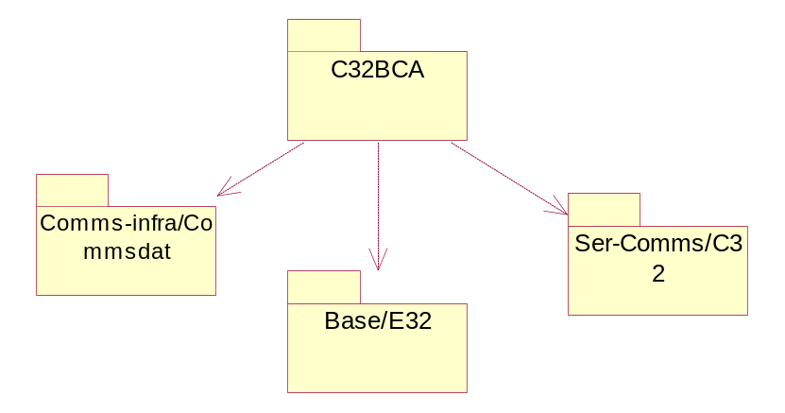
Figure 3 C32BCA External Dependencies

API Purpose - Further Elaboration
The BCA interface is a published partner interface. Currently it is used just by NIFs (rawip.nif and ppp.nif) however future strategy will see the BCA interface used by TSYs to remove interconnect dependencies from the TSY.

Telephony/Reference and Test TSYs
The Etel server provides abstract base classes for each of the objects from which all TSY modules are expected to derive and implement the virtual functions, e.g. phones are opened from a phone factory object, which similarly has an abstract base class in the server and implementation in the TSY. This means that the Etel Server TSY API is created by five abstract base classes: those representing phones, lines, calls, faxes and extensions. Symbian OS provides two reference versions of the TSY, the Multimode TSY (MM.TSY), and the Simulator TSY (SIM.TSY).
MMTSY uses the AT command interface to communicate with the phone or modem and it provides the GSM and GPRS functionality. Client requests issued through the Multimode Etel API are translated by the MMTSY into ETSI-standard AT commands and sent to the phone/modem, via an Infra-Red (IR) or Serial link. Similarly, the modem’s response to these commands is also interpreted by the MMTSY and passed back through Etel to the Client.
SIM TSY is a simulator module designed to enable automated testing of a range of components within the company such as Telephony, Javaphone and Networking components in a simulated GSM and WCDMA mode. The Simulator TSY module is designed to sit beneath Etel and since it will not communicate with any real hardware (modem, phone), it will use static configuration data and dynamic system agent notifications to achieve its simulation. The following diagram describes the location of the Simulator TSY and its interfaces to other system and telephony components.

Client App

ETel Packet API
ETel MM API
Client
Server Boundary
ETel Server

Simulator TSY

KEY

Configuration
File
Owned by the Simulator TSY

System
Agent
Existing System Component

Figure 4 SIMTSY Architecture

The simulator Sim.TSY, provides the (simulated) core and multi-mode functional implementation on the TSY side exposed by ETel/ETelMM APIs.

Telephony/HWRM
The Hardware Resources Manager (HWRM) was added to the Symbian OS in v9.4 as part of the Core OS agreement. It provides client APIs for controlling the light(s), vibra, FM transmitter (FmTx) and battery resources of the device. It also has additional responsibility of publishing certain power state related P&S properties.

Key Internal Relationships and Dependencies
The following component diagram shows the internal architecture of the Hardware Resources Manager.
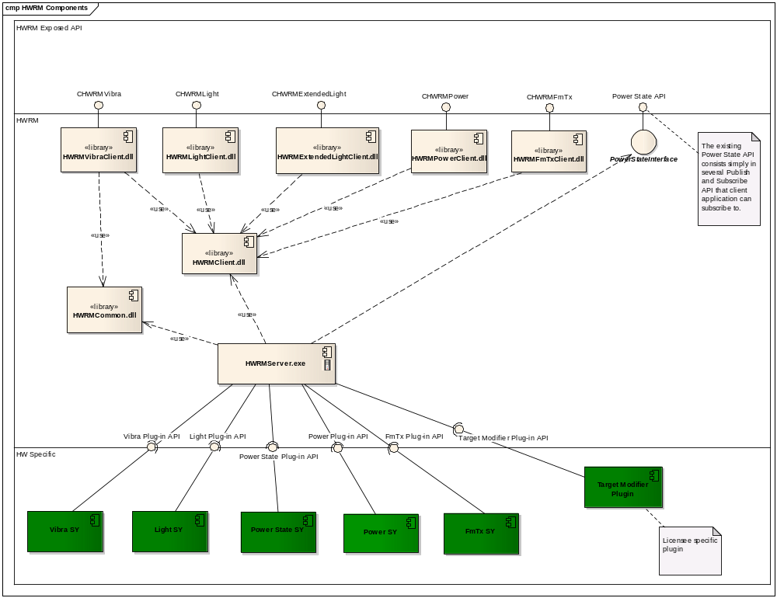
Figure 5 HWRM Architecture

The HWRM implements a client-server architecture, with the HWRM Server processing the requests from the client DLLs and sending them to the hardware-specific adaptation plug-ins.
There is an additional DLL, hwrmuiplugin.dll. This is an ECOM plugin that provides its clients (the Vibra and Extended Light client DLLs) with UI awareness, thus enabling them to respond to UI events affecting the client applications using the DLLs.
For each HWRM functional area (Light, Vibra, FmTx and Battery or Power State), the HWRM provides an adaptation plug-in API to achieve device independency. Licensees implement the adaptation plug-ins, which are loaded via the ECOM mechanism and implement the plug-in API to process the commands to the hardware and send the response to the server.
See [[11] for more detail on the design of the HWRM.

Key External Relationships and Dependencies
The following diagram shows the components on which HWRM depends. All dependencies shown are static dependencies. The only dynamic dependencies are internal ones (see plug-ins in 3.2.3.1).
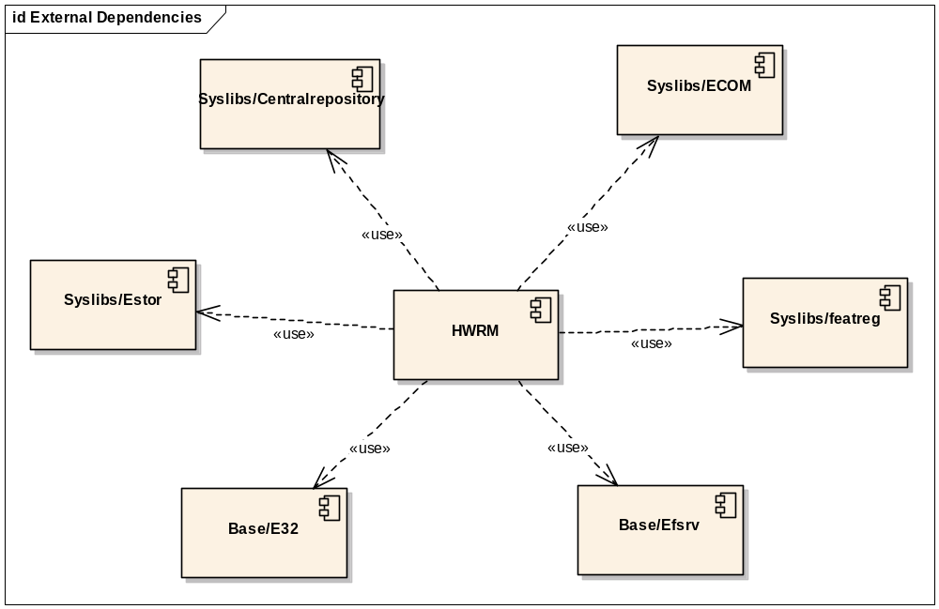

API Purpose – Further Elaboration
The Hardware Resources Manager provides five main client APIs: the Light API and Vibra API are provided to control the vibra and lights of the device. The FmTx API provides control on the device’s FM transmitter. The Power State API allows clients to receive notifications of battery related events. The Power State API is not an API in the function sense but merely a set of Publish and Subscribe keys that are updated by the HWRM server. Finally, the Power API provides advanced functionality, like periodic measurement notifications, and a proper API for battery related information.
The Target Modifier Plug-in API is an additional API that is provided to allow licensees to define device specific resource (i.e. lights, vibra) behaviour according to particular physical characteristics of the device, e.g. when turning lights on/off, inactive targets (covered or otherwise hidden or just not active for other reasons) can be removed from the set of available targets. At the moment, only Light Target modification is supported.
There is an additional Extended Light API, which is available to OEMs only and is no more than a duplicated Light API that permits controlling more light targets on the device. The basic Light API allows control of 8 light targets whereas the Extended Light API allows control of 27 light targets.

Architectural Description and Elaboration

HWRM
The following points should be mentioned:
- The HWRM Server is a system critical process and is loaded at operating system startup.
- There are two client-side light DLLs, each exposing a client API. The Light API (hwrmlightclient.dll) is publishedAll (and sometimes called “Basic” or “SDK” Light API) and is restricted to control the basic and secondary display and keyboards, whereas the Extended Light API (hwrmextendedlightclient.dll) is publishedPartner and permits the control of 8 further custom light targets. In order to minimise code duplication, the Light DLL forwards all requests to the Extended Light DLL.
- Some Light, Vibra and FmTx behaviour depends on whether the client making the requests is in the background or in the foreground, despite the HWRM component being in a UI independent layer. This UI awareness is achieved through the use of an ECOM plugin (hwrmuiplugin.dll), which allows the HWRM Light, Vibra and FmTx DLLs to respond to UI events affecting the client applications.

System Architectural Requirements
All the Baseband Adaptation components, except the HWRM, run within the Comms process. They are also all plug-in components.
- TSY is a plug-in to Etel
- BCA is a plug-in to NIFs
Since the Baseband Adaptation stream provided adaptation components that plug-in to existing architecture the use-cases for this stream are dictated by the exposed client-side APIs

Security

Data caging

HWRM
HWRM uses a configuration “ini” file to set priorities of the different client applications. This file is secured by storing it in the private directory of the HWRM server process.
The Central Repository initialization files is also stored in the private directory of the HWRM server process.

Backup and restore

HWRM
Some Central Repository keys used by the Harware Resources Manager are writable. HWRM uses the Backup and Restore mechanism and stores the backup registration file in the private directory of the HWRM server process.

Capability ranges

TSY
Etel polices the capabilities of client applications when they attempt to use the TSY in most cases. The exception is when an Etel extension is called. In this case it can not be policed by Etel because the required capabilities are not known. To get around this problem the TSY publishes a list of the capabilities required for each extension that it implements.
The list of extensions implemented by the TSY is platform specific and therefore it is not possible to list here the capabilities explicitly policed by the TSY.

HWRM
The HWRM Client DLLs and the UI ECOM plugin have a capability set of All -TCB.
The HWRM Server has the following capabilities:
ReadDeviceData WriteDeviceData ProtServ CommDD.

Further Information

References
No. | Document Reference | Version | Description
[2] | 3GPP TS 07.07 | 7.8 | AT command set for GSM Mobile Equipment (ME)
[3] | 3GPP TS 27.010 | 4.2 | Terminal Equipment to User Equipment (TE-UE) multiplexer protocol
[4] | 3GPP TS 07.05 | 7.01 | Use of Data Terminal Equipment - Data Circuit terminating;  Equipment (DTE - DCE) interface for  Short Message Service (SMS) and  Cell Broadcast Service (CBS)
[5] | SPUD_Design.doc | 1.2 | //EPOC/master/common/generic/networking/spud/Documentation/
[6] | Etelmm_API_Design_Document.doc | 1.25 | //EPOC/master/common/generic/telephony/etelmm/Documentation/
[7] | Etel_Packet_API_Design.doc | 2.0 | //EPOC/master/common/generic/telephony/etelpckt/documentation/
[8] | (U)SAT_Etel_API_Specification.doc | 2.1 | //EPOC/master/common/generic/telephony/etelsat/documentation/
[9] | Baseband Adaptation Subsystem Functional Specification.doc | 2.2 | //EPOC/master/common/generic/telephony/documentation/
[10] | SGL.GT0117.290 | 1.1 | PSD_Agent_Design.doc
[11] | HWRM Design.doc | 5.1 | //EPOC/master/common/generic/telephony/hwrm/documentation/HWRM Design.doc

Open Issues
None.

Glossary
The following technical terms and abbreviations are used within this document.
Term | Definition
AGT | Agent
BC | Binary Compatibility
BCA | Baseband Channel Adapter
C32 | Symbian Serial server
CSD | Circuit Switched Data
ESock | Symbian Socket server
Etel | Symbian Telephony server
HWRM | Hardware Resources Manager
MCL | Symbian Master Code Line
ME | Mobile Equipment
MAP | Mobile Application Part
MS | Mobile Station
MT | Mobile Terminal (3G terminology)
NIF | Network Interface Module
PDP | Packet Data Protocol
SPUD | Secondary PDP context UMTS Driver
TE | Terminal Equipment (3G terminology)
TI | Texas Instruments
UE | User Equipment (3G terminology)
USIM | UMTS Subscriber Identity Module (3G terminology)

Document History
Date | Version | Status | Description
02-03-2009 | 3.4 | Issued | Updated following TRP removal
26-01-2009 | 3.3 | Issued | Deleted CDMA references as part of PREQ 2002
21-05-08 | 1.3 | Issued | Updated after submission of PREQs 1944, 1976, 2000, 2066
17-09-2007 | 1.2 | Issued | Updated with information on the Hardware Resources Manager component
02-08-2006 | 1.1 | Issued | Updated with information from v9.4 and with the TSY components moved from the Telephony Services documents.
 | 1.0 | Issued | Previous version.

